National News Literacy Week – January 25-29th
This is a national awareness program aimed at promoting news literacy and to provide tools for becoming better-informed citizens.
The News Literacy Project has made available resources to promote and teach about news literacy through this year’s theme: “News Literacy Fitness”
3 ways to get involved and support National News Literacy Week:
- Visit NewsLiteracyWeek.org to test your “news literacy fitness” and take the pledge to become more news-literate. 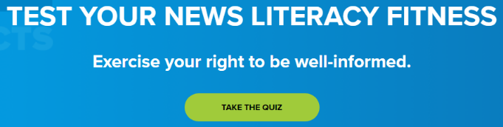
- Watch NLP’s new Checkology virtual classroom lesson “Conspiratorial Thinking” to learn how and why conspiracy theories develop and how to avoid falling for them. Note: this is a rather lengthy lesson with 46 segments that teaches people to understand key components of conspiracy theories, including:
- What a conspiracy theory is and what separates it from other kinds of misinformation.
- How a conspiracy theory can be captivating despite a lack of evidence to support it.
- The real-world consequences and the political and social impact of conspiracy theories.

- Join the conversation on social media at #NewsLiteracyWeek. Check out the Sabino Library Weebly blog from more information about the News Literacy Project at: https://sabinolibrary.weebly.com/whats-new/category/all
News Literacy Week: https://newslit.org/news-literacy-week/

